1. Install git.

Download the link with browser https://git-scm.com/downloads

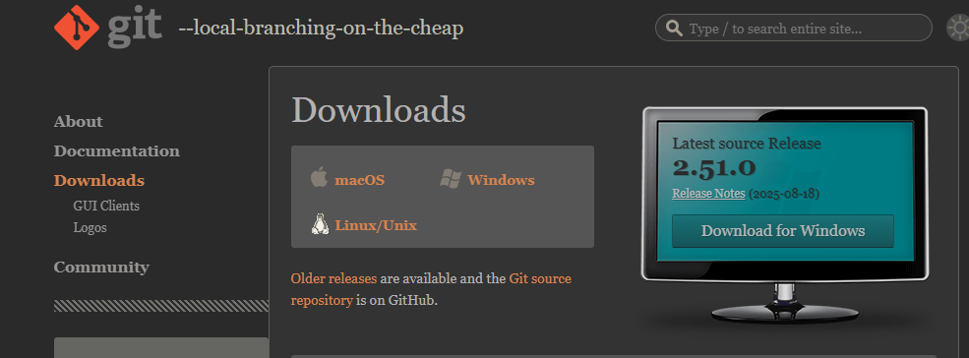

1. Create a repo in github with README.md and .ignore file.

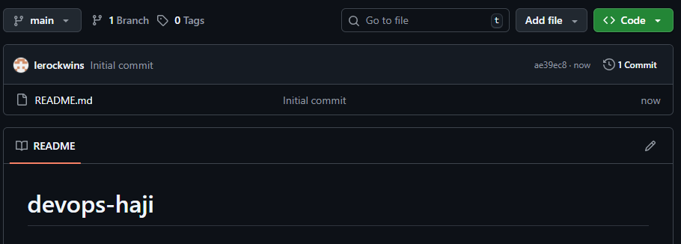

* To create a repo use new and gave REPO NAME and
* Give a permission to read-me & ignore the file

1. Clone the created repo to local.

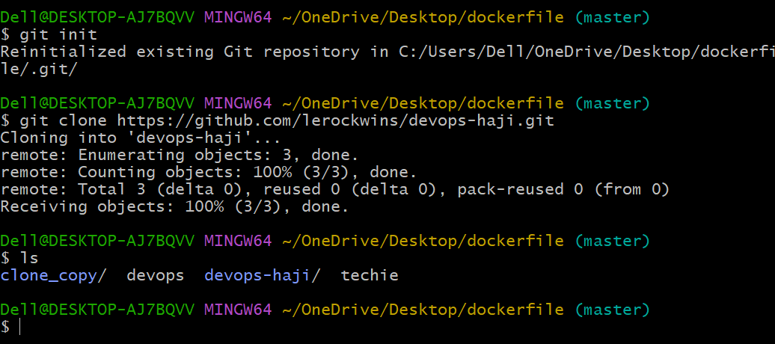

* For clone use the command of “git clone and ssh key from git hub” of a directory which uh want to clone from git hub to local.
* Then take the copy link of github and paste gitclone .

1. Create two files in local repo.

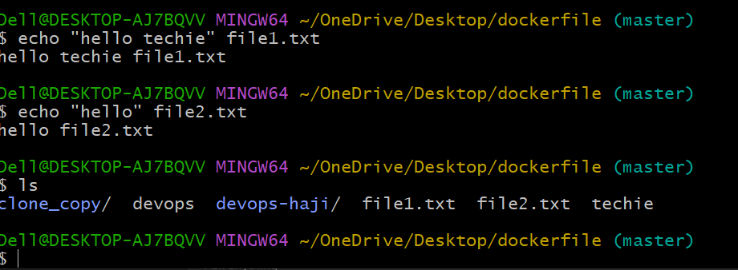

* Create a touch file1.txt and file2.txt
* And git add .
* Then a commit id
* Then ls
* Then use a echo and gave message to file1 nd file2.txt

1. Commit two files and push to central Repository.

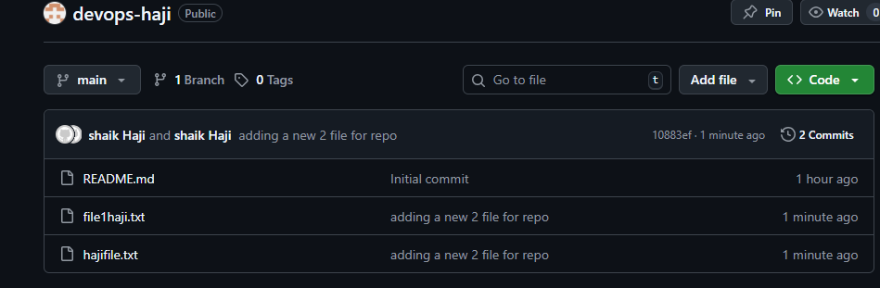

* Create a touch file1.txt and file2.txt
* And git add .
* Then a commit id
* Then ls
* Then git push check in the central repo .

1. Create a branch in local and create a sample file and push to central.

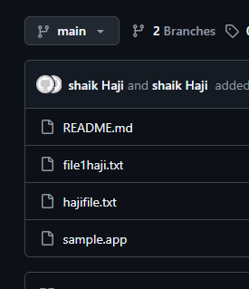

* Create new branch name with release
* Nd create a sample .app file
* Git add .
* Git commit “messege”
* Then git push
* Then git push -u origin (release) branch name
* Then open a browser and refresh it branch will add and file add.

1. Create a branch in github and clone that to local.

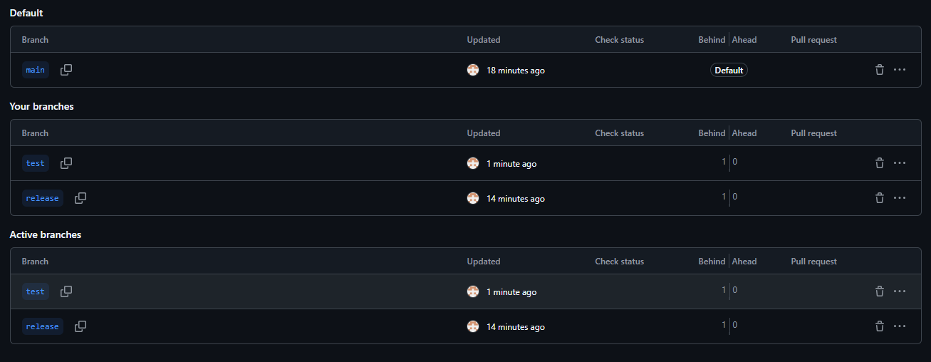

Create a branch name with name of test.

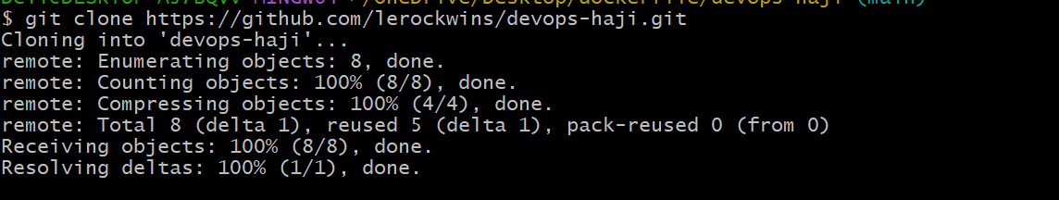

Git clone and https key and enter

Evrything in clone to new branch

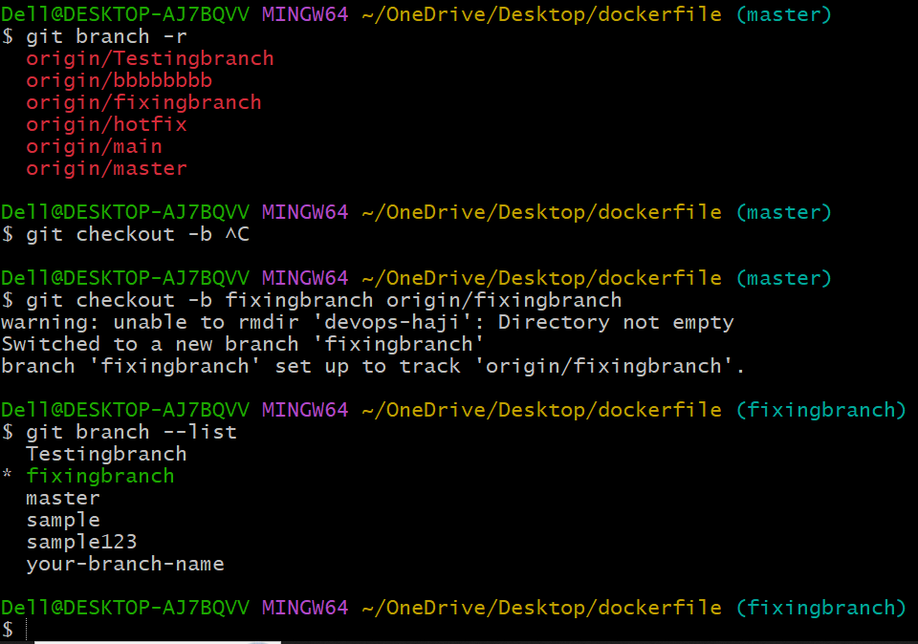

1. Merge the created branch with master in git local.

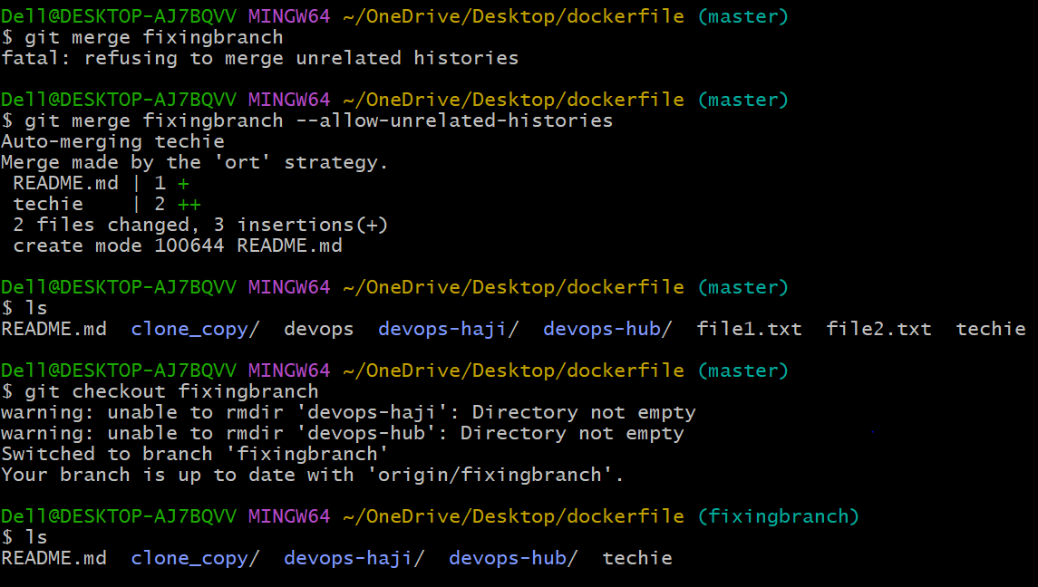

* Create a new branch in git local with name of fixingbranch
* Then use git merge fixingbranch
* So it’s a command of refusing so I used the command of git merge --allow-unrelated stories”
* Then ls file are merge in different branch
* Then checkout to fixingbranch and check the ls
* Merge files are showing below.

1. Merge the created branch with master in github by sending a pull request.

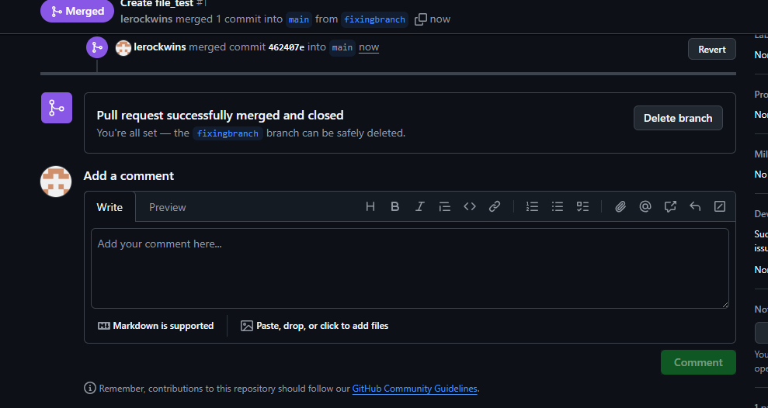

* Created new branch with the name of fixing branch and created a new file there.
* Nd in top there is a option to pull request after that its showing comapre and pull after the commit chnges and confirm merge and pull.

1. Create a file in local and send that to branch in github.

* Create a file name with file1
* Then git add . a file in local branch
* Nd checkout in ur branch
* Add a commit messge
* And give a git pull
* And git push

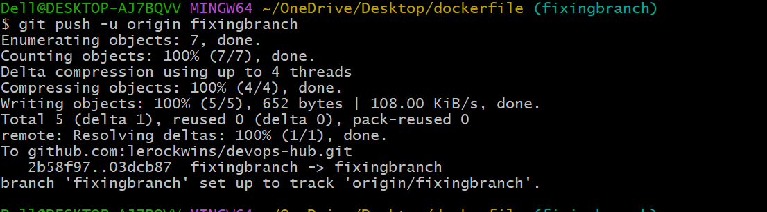

* After that we are entering in git hub and refresh the page it will show the file name with file1.

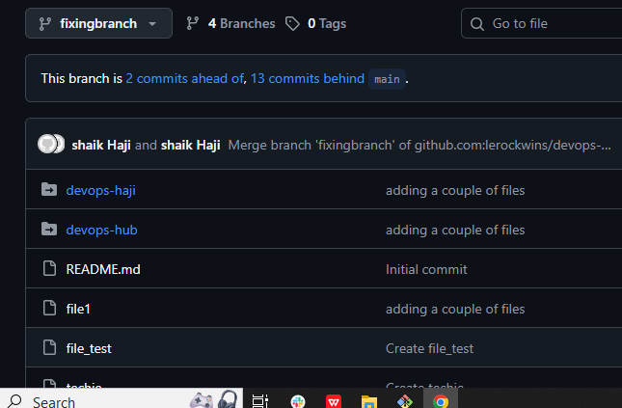

1. Clone only a branch from github to local.

* Create a new branch name with clone.tst

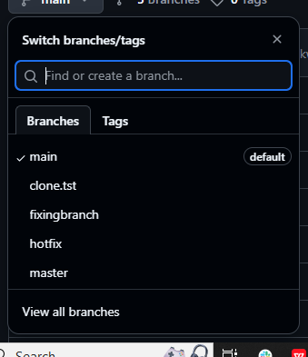

* To delete the devops hub use a command of rm -rf devops haji
* Then git clone --branch name and --single-branch and copy of the url it will clone to one to other.

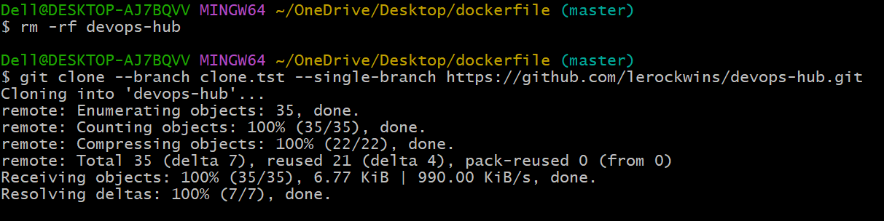

1. Create a file with all passwords and make that untrackable with git.

* Create a file with password.txt
* Then git add file name and and a commit “gitignore password”
* Nd push to origin
* Open a github browser it will reflected there and open a file with commit id it will show uh a secreat password what uh gave in side of that password.txt file.

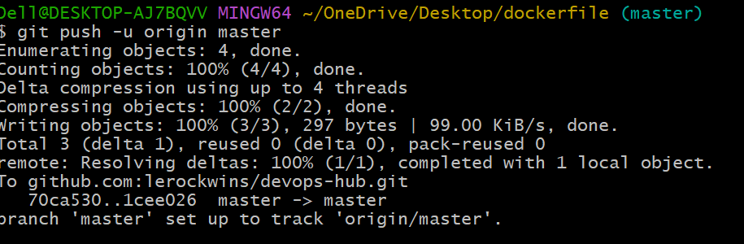

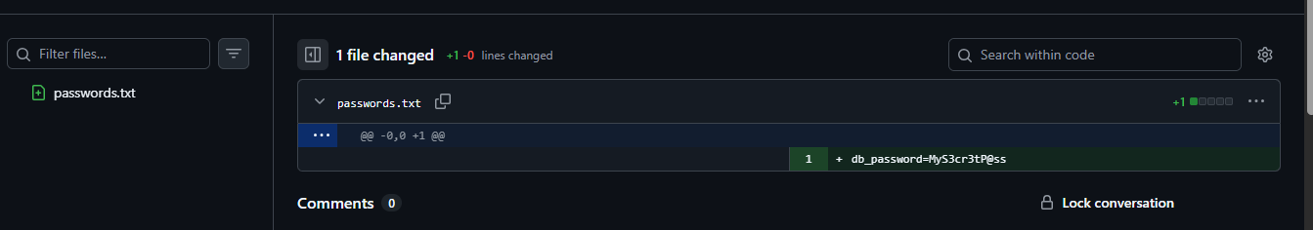

1. Make a commit and make that commit reset without savings changes.

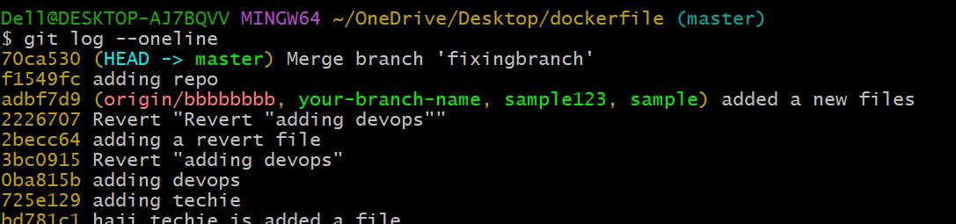

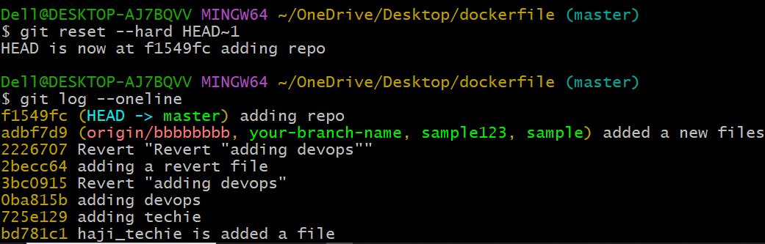

1. Revert a commited commit to the older version.

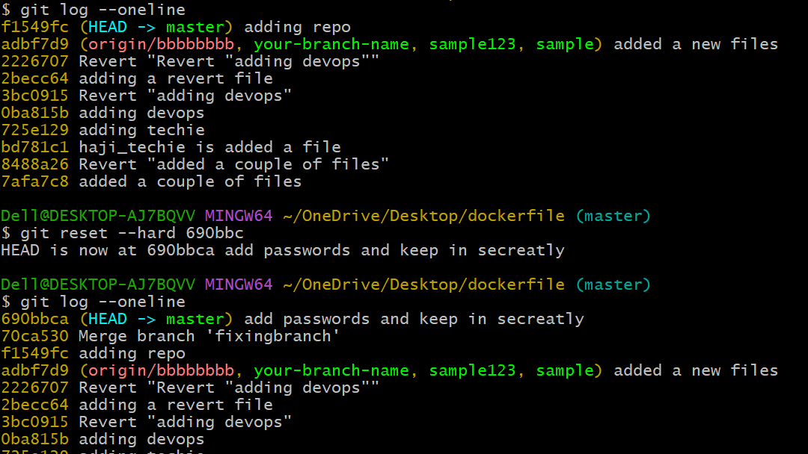

1. Push a file to stash without savings the changes and work on another file.

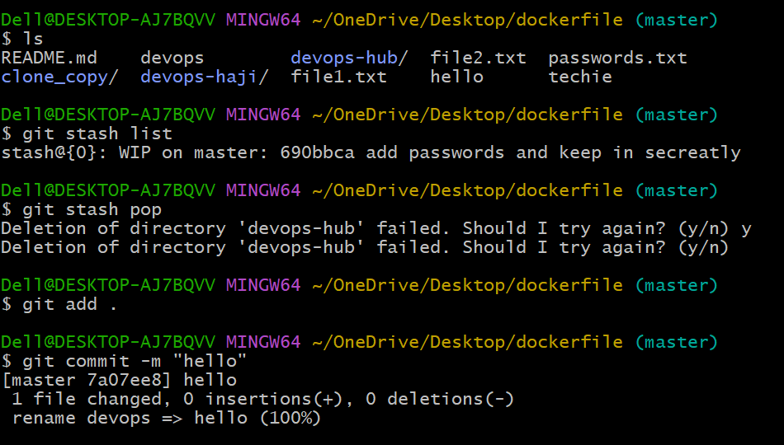

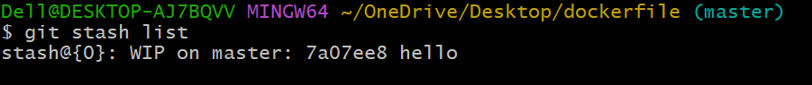

1. Undo the stash file and start working on that again.

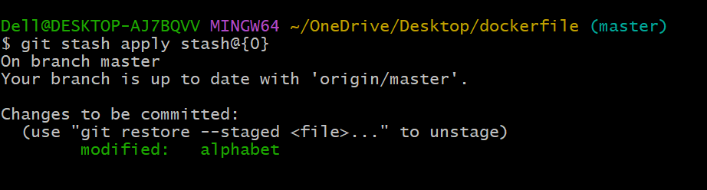

1. Generate a ssh-keygen and configure into github.

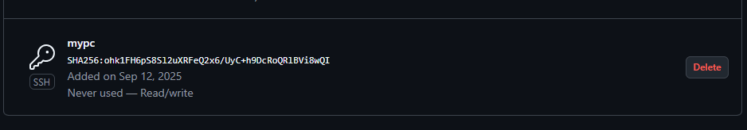

1. Configure webhooks to github.
2. Basic understanding of .git file.

* Git is hidden a directory of created automatically when uh run git clone init.
* This folder is **local data base of git**.
* It lives at the **root of your Git project**.

1. Check all the logs of git.

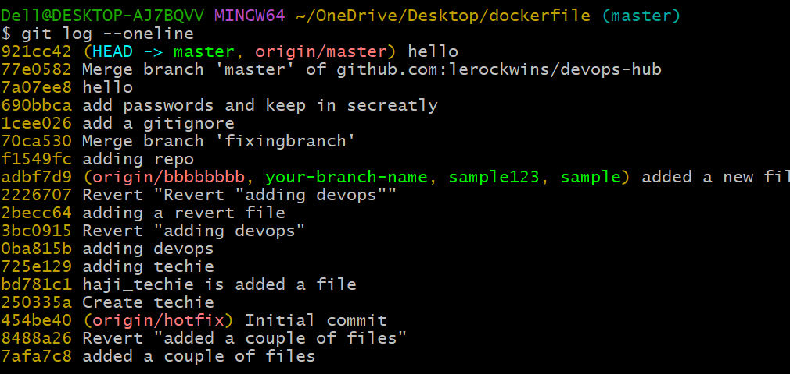

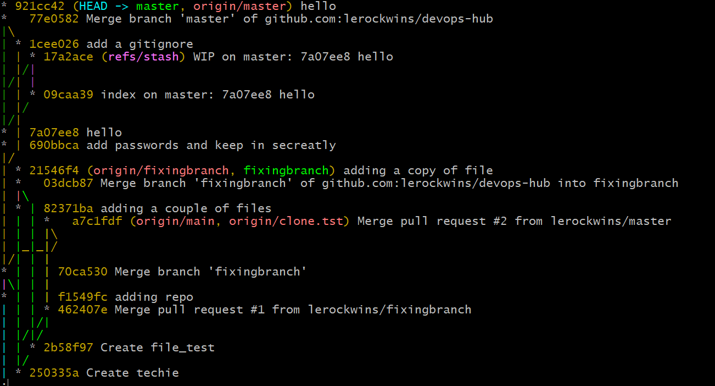

1. Rename the commit message.

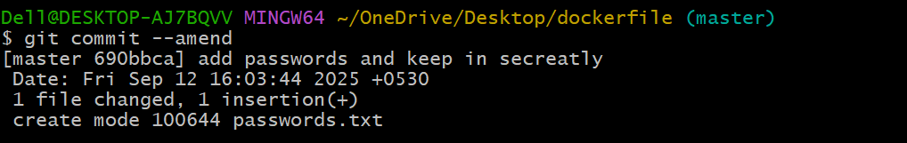

1. Merge multiple commits into single commit.